 | Student Name _______________________  Eastern Goldfields College  Mathematics Applications U1 2016  Investigation 1 – Investments

Task weighting: 5% This investigation is in two parts.

Part A Take home - This is completed for homework and will lead you through a series of activities that deal with investing. (3 marks)

Part B Validation - 90 minutes in class, under test conditions, that will test your understanding of the statistical investigation in Part A. You will have access to technology with a spreadsheet function and/or calculator. (31 marks)

INTRODUCTION
Your great-grandmother gives you $3000. She tells you that you must keep it in a bank account for 4 years before you spend it.

Part A of this investigation looks at a variety of ways you could invest this money.

Investment Type 1 – SIMPLE INTEREST
Simple Interest – is the interest paid on the principal, or amount, invested.

Bank 1
Bank 1offers 6% per annum for the life of her investment. Use the Simple Interest formula to calculate:
- The amount of interest you would earn.

- Your total investment at the end of your 4 years.

Bank 2
Bank 2 offers 6.75% p.a. However, you must invest for a minimum of 5 years. Complete the table below to determine how much you will earn.

Time (Years) | Principal | Simple Interest | Balance at the End of the Year
1 | $3000 | 0.0675 x 3000 = $202.50 | $3000 + $202.50= $3202.50
2 | $3202.50 | 0.0675 x 3000 = $202.50 | $3202.50+ $202.50= $3405
3 | $3405 | 0.0675 x 3000 = $202.50
4
5
- How much interest is earned at the end of the 5 years? _______________

- What is the total investment of the loan at the end of 5 years? _______________

Investment Type 2 – COMPOUND INTEREST
Compound Interest – is the interest paid on the sum of the principal and any accumulated
interest.

Bank 3
Bank 1offers 4.24% per annum, compounded annually, for the life of her investment. Work out the pattern and complete the table below to determine how much you will earn.

Rate = % ÷ N ÷ 100, N = the number of times interest is calculated within a year.

N = 1, Rate = 4.24 ÷ 1 ÷ 100 = 0.0424

Time (Years) | Principal | Compound Interest | Balance at the End of the Year
1 | $3000 | 0.0424 x 3000 = $127.20 | $3000 + $127.20= $3127.20
2 | $3127.20 | 0. 0424 x $3127.20= $132.59328 | $3127.20+ $132.59328= $3259.79328
3 | $3259.79328 | 0. 0424 x $3259.79328= | $3259.79328+
4
5

- How much interest is earned at the end of the 4 years? _______________

- What is the total investment of the loan at the end of 4 years? _______________

Bank 4
Bank 2 offers 3.5% per annum, compounded 6 monthly for the life of her investment. Work out the pattern and complete the table below to determine how much you will earn.

N = interest is calculated twice a year, so N = 2, Rate = 3.5 ÷ 2 ÷ 100 = 0.0175

6 month (year) | Principle | Compound Interest | Balance at the End of the Year
1 (0.5) | $3000 | 0.0175 x 3000 = $52.50 | $3000 + $52.5= $3052.50
2 (1) | $3052.50 | 0. 0175 x $3052.50= $53.41875 | $3052.50+ $53.41875=
3 (1.5)
4 (2)
5 (2.5)
6 (3)
7 (3.5)
8 (4)

- How much interest is earned at the end of the 4 years? _______________

- What is the total investment of the loan at the end of 4 years? _______________

Bank 5
Bank 2 offers 2.75% per annum, compounded quaterly for the life of her investment. Work out the pattern and complete the table below to determine how much you will earn.

Quarterly (year) | Principle | Compound Interest | Balance at the End of the Year
1 (0.25) | $3000 | 0.006875 x 3000 = $20.625 | $3000 + $20.625= $3020.625
2 (0.5) | $3020.625 | 0.006875 x $3020.625=
3 (0.75)
4 (1)

- How much interest is earned at the end of the 4 years? _______________

- What is the total investment of the loan at the end of 4 years? _______________

Best Investment Option
Answer the following questions on a separate piece of paper and attach to this document.
- Which is the best option for Investment Type 1 – Simple Interest?
- Which is the best option for Investment Type 2 – Compound Interest?
- For both Investment Types, which is the best investment option? Justify your reason.

Investment Type 3 – ASSETS

- Research the meaning for each of the following terms:
- Asset

- Lease

- Inflation

- Depreciation

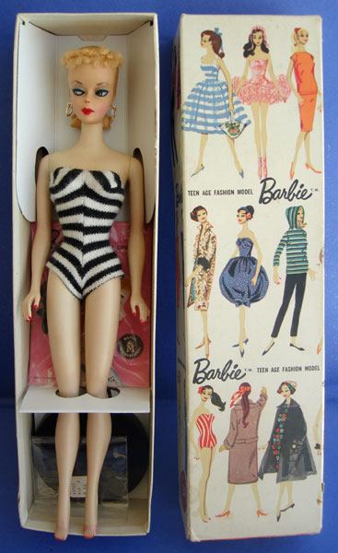
- Your great-grandmother has also offered to give you a Barbie Doll. She purchased this doll in 1959. It is still in excellent condition and has never been removed from its packaging (see image on right).
This Barbie Doll cost your great-grandmother $3. If it had a constant inflation rate of 17.35% p.a., how much is the doll worth today? Round your answer appropriately.


- Your great-grandmother has also offered to give you her car. She purchased her Toyota Corolla brand new in 2006 for $25 950 and it depreciated at a rate of 10.5% p.a. What is of the car worth today. Round your answer appropriately.

